**Experiment - 01**

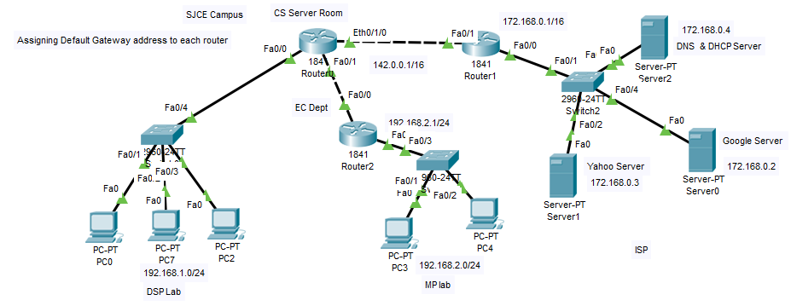**Cisco Packet Tracer - DHCP and HTTP, DNS Servers**

**Objectives**

1. Configure Static IPv4 Address to DNS & DHCP server as mentioned in the topology.
2. Configure and Verify DNS Records
3. Configure and Verify DHCP Process.
4. Configure a Web server and verify the HTTP request and Response.

**Procedure to Configure the above in the given network topology as follows**

1. Assign an IP address and Subnet Mask and Default Gateway Address to DNS and DHCP Server as mentioned in the network topology.
2. Enable the service of DNS and DHCP in that server.
3. In the Same Network make other two servers as Web Server (For Example: One as GOOGLE Server and another as Yahoo Server) Just by changing their index Web Page.
4. After enabling the DHCP service on the server, configure each router with the following configuration (using router as relay agent) Since one DHCP server where we can’t assign IP configuration to each independent Network. Enter into CLI command Mode and type the following commands.

Router > Enable (Enter)

Router# Configure terminal (Enter)

Router(config)# interface Fast Ethernet 0/0 (Enter)

Router(config-if) # ip helper-address 172.168.0.4 (DHCP Server IP) (Enter)

1. Visit to each Host in each network, Go to Desktop, then Ip configuration and change the option for DHCP Request.
2. Check Whether all the Host are assigned with IP Configuration.
3. If each host getting IP address, repeat the above steps 5 & 6 in Simulation Mode and trace each packet is exchanged between the client and the DHCP Server (Verify the DORA Process).
4. Similarly verify the DNS Querying Process before resolving the IP address from the Domain Name, Same should to viewed and verified in simulation Mode.
5. Similarly verify the HTTP request and response Process and observer TCP connection prior to HTTP Request and Response, Same should to viewed and verified in simulation Mode.
6. Take the screen shot of the results which is verified in Simulation Mode and write the inference.
7. After the completion of the experiment, answer all the viva question given below in the lab itself.

**LAB – 01 Viva-Voce Questions**

**Topics: - DNS & DHCP**

1. What is DHCP?
2. Explain the Process of DHCP?
3. What is an IP lease?
4. Describe the integration between DHCP and DNS?
5. What is the default duration of a lease?
6. What is IP Reservation?
7. How can you prevent unauthorized laptops from using a network that uses DHCP for dynamic addressing?
8. Can DHCP support statically defined addresses?
9. Purpose of DHCP Relay agent?
10. What is DNS?
11. How many types of DNS Types of records are there?